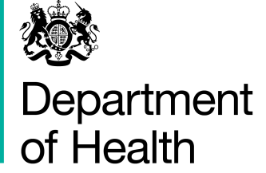

14 July 2014

To: All-England Chief Pharmacist Group

NHS Controlled Drug Accountable Officers

**CONTROLLED DRUGS AND WHOLESALE DEALER’S AUTHORISATION FOR HUMAN USE/WHOLESALE DEALERS’ AUTHORISATIONS**

In February 2014, Dr Keith Ridge wrote to the All-England Chief Pharmacist Group providing information on the requirements, when supplying drugs, to hold a wholesale dealer’s authorisation for human use (WDA(H)) and controlled drugs licence, following changes to the Medicines Act in August 2012.

Keith’s letter advised that further information about the requirements would be published. This is now ready and I am grateful for the help and support of Home Office, Medicines and Healthcare products Regulatory Agency (MHRA) and NHS colleagues in its preparation.

A copy is enclosed with this letter, which includes Keith’s original letter at the end. There is a section on frequently-asked questions, which includes various matters of particular relevance to hospices.

If you have any queries on:

* MHRA wholesale dealer’s authorisation for human use, please contact PcL enquiry line on 020 3080 6844 or email: [pcl@mhra.gsi.gov.uk](mailto:pcl@mhra.gsi.gov.uk)
* Home Office controlled drug licences, please contact the Duty Compliance Officer on 020 7035 8972 in the first instance.

I am happy for this letter to be circulated widely to your networks and colleague providers who may have an interest.

You may wish to note that the Department is setting up an ad hoc working group with wide representation from government, regulators, the NHS and providers to monitor and evaluate any risks to supplies arising for local hospices. It will be chaired by Gul Root, Principal Pharmaceutical Officer here at the Department and first meets on 31st July 2014. If you would like more information or have further general enquiries, please contact Gillian Farnfield here at the Department in the first instance ([gillian.farnfield@dh.gsi.gov.uk](mailto:gillian.farnfield@dh.gsi.gov.uk))

Yours sincerely

Jeannette Howe

**Head of Pharmacy**